EI⁴ = Inspiration, Empowerment,
Wisdom and Community…
Applied Emotional Intelligence Workshop
January 20-21, 2023 ~ Hilton Carillon Park ~ St. Peterburg, Florida

Emotional Intelligence Bob Frazer, Jr., DDS, Bill Woodburn, MEd, LPC to the 4th Power… Lisa Alvarado, Office Coordinator & HRC
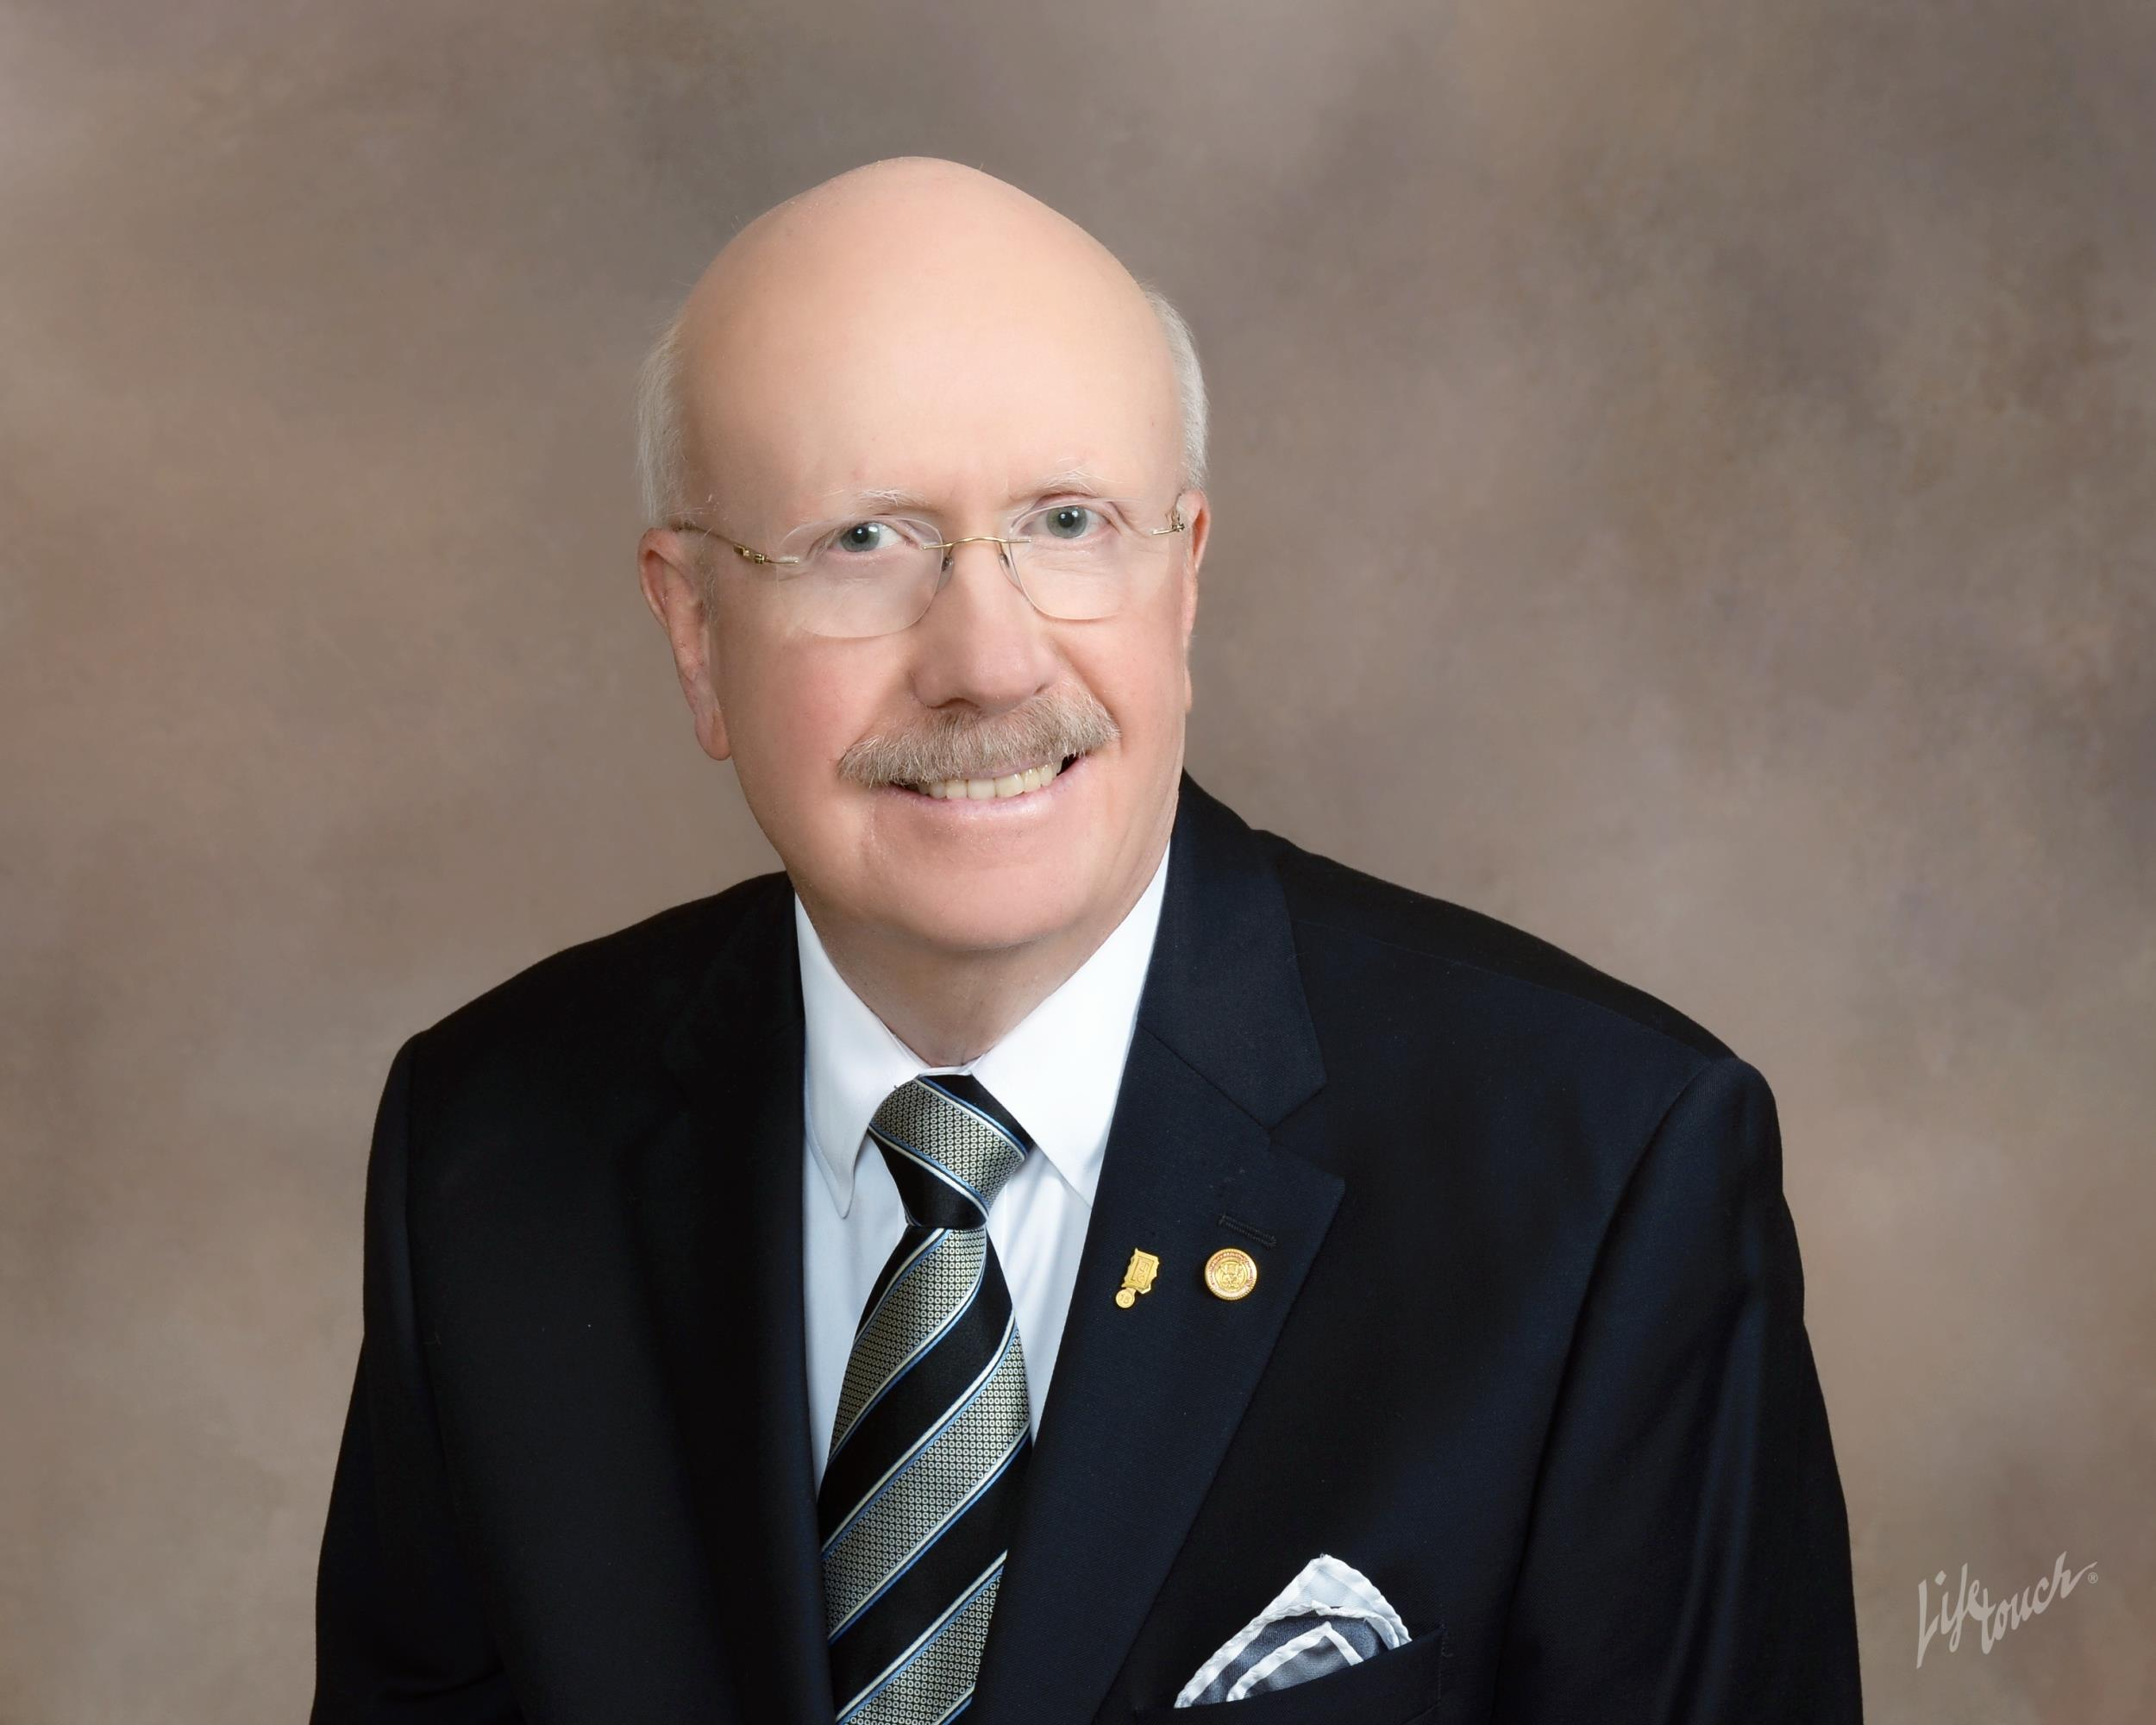
Empower yourself and your team through our most advanced workshop ever. EI⁴ combines the talents of an experienced dentist and coach, a professional counselor and key team member coach to give you in-depth, practice-tested learning. Through new, problem-focused learning methods and hands-on skills practice, EI⁴ takes participants to the cutting edge of new research and best practices - all in a supportive and fun environment.

Bob Frazer, DDS, leads you through top 2% practice tested, results targeted EI skills to answer your challenges, ensure excellent team performance and provide a truly “Wow” - remarkable and transformational patient experience.
Robert Frazer, Jr., DDS

“In nearly 30 years of CE, this was the best non-technical course I’ve ever attended. I was able to immediately apply what I learned with positive results.”
Don Kleier, DDS, MS

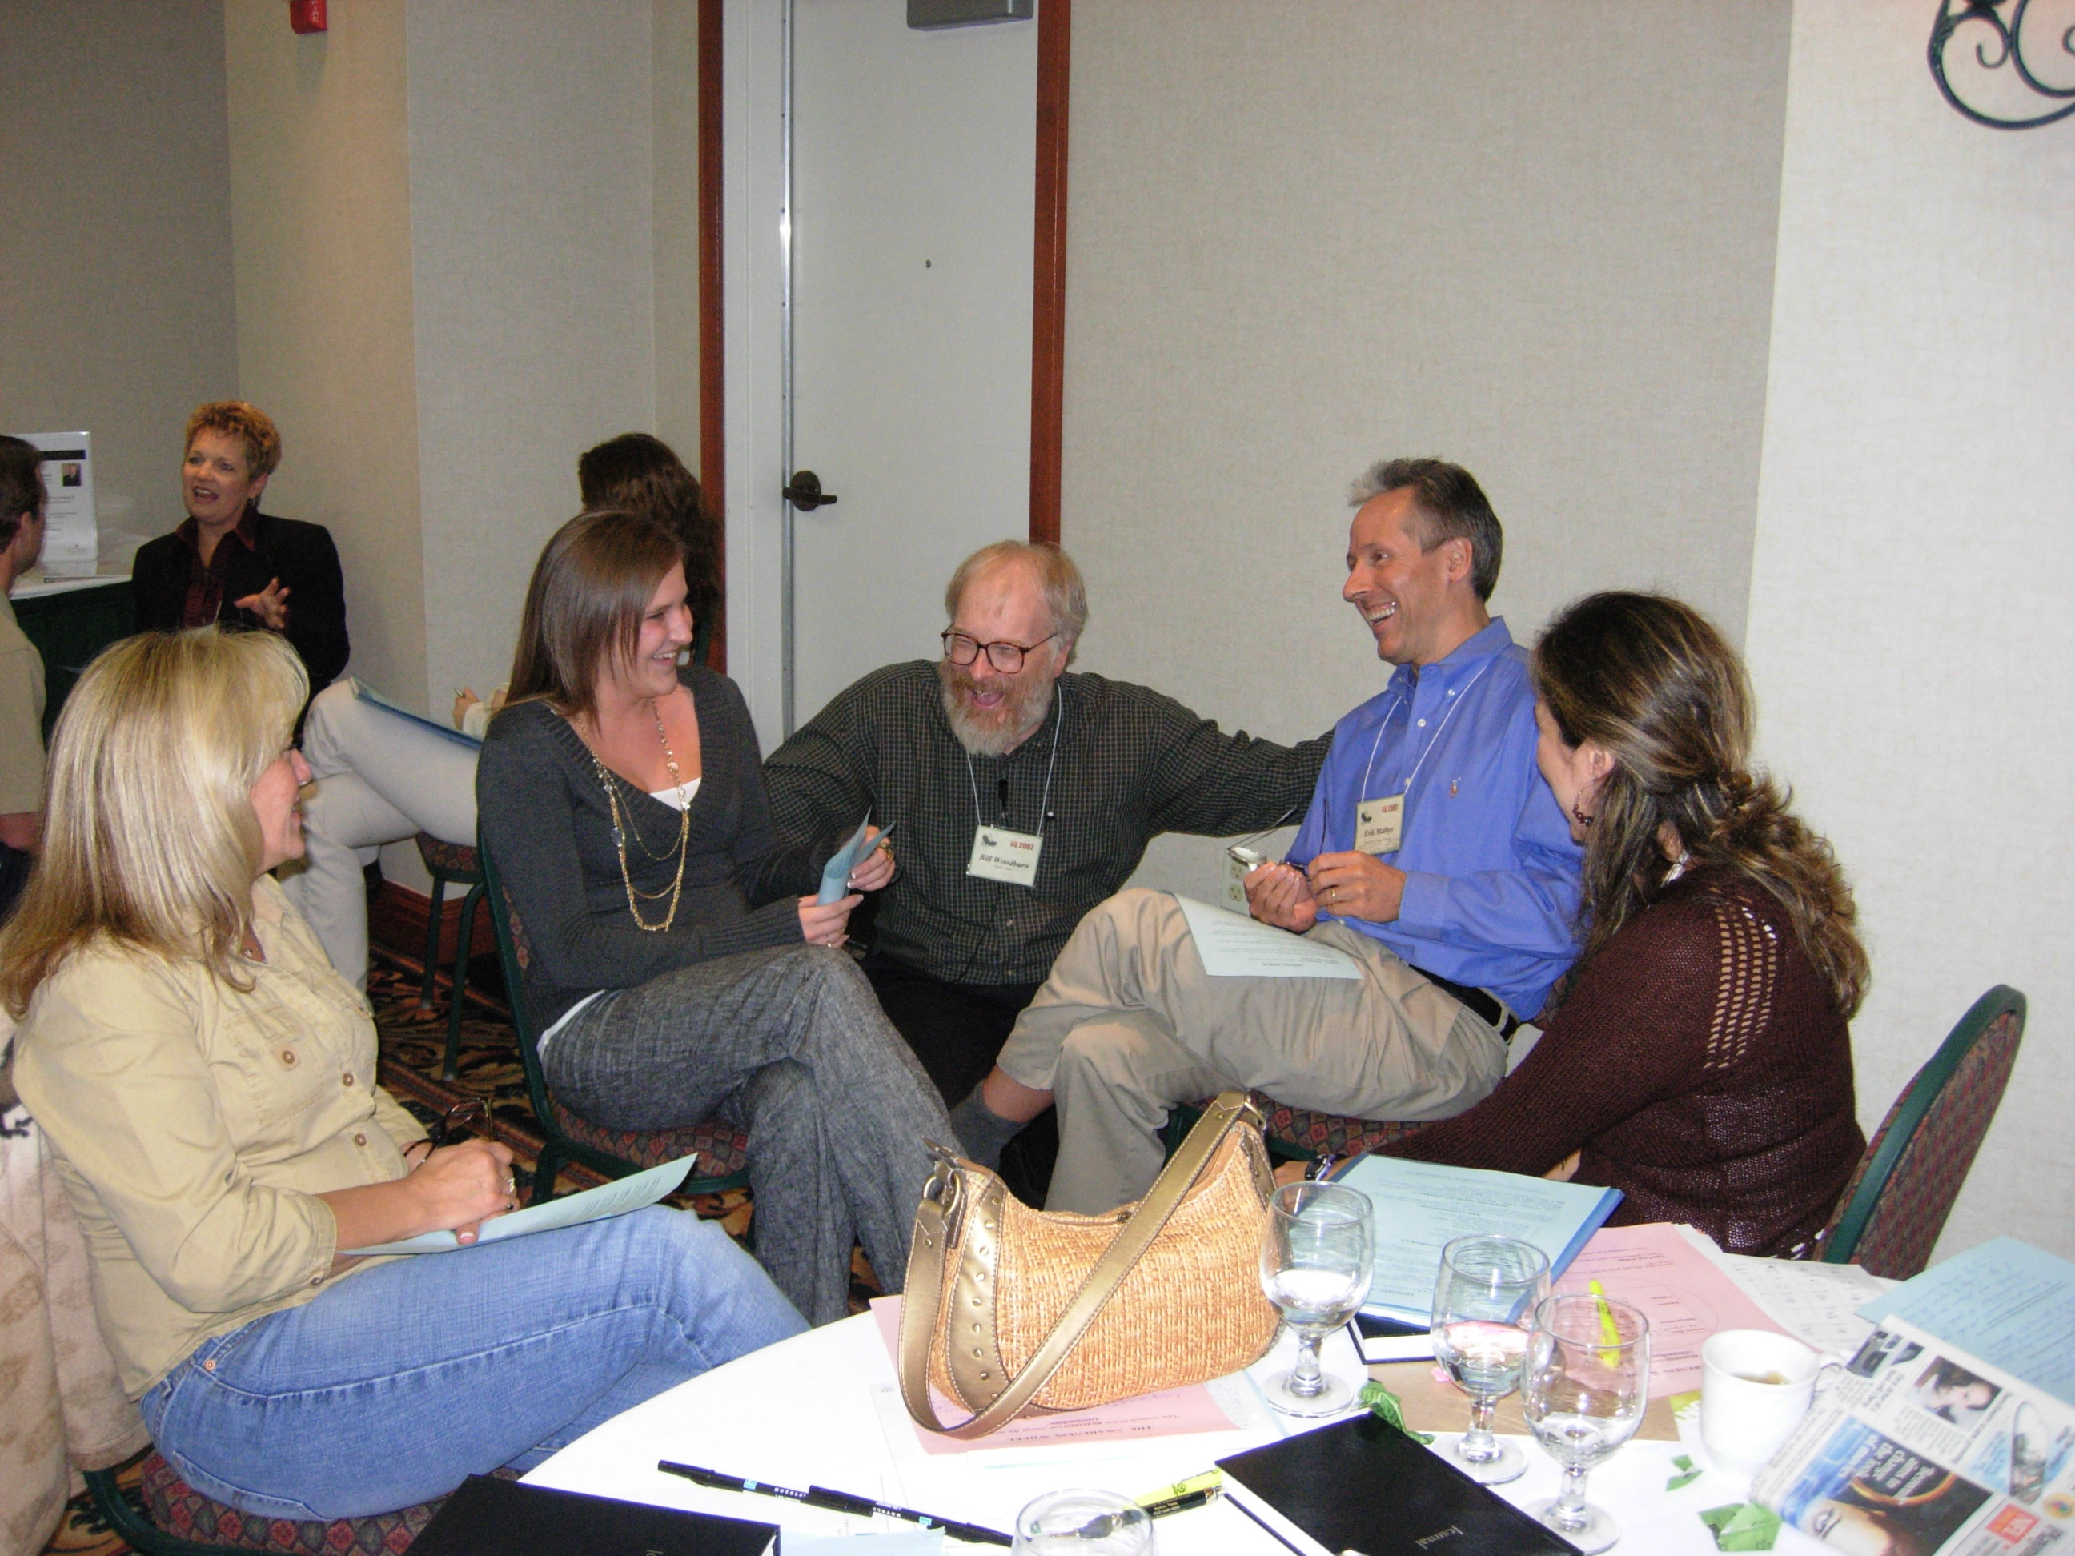

Emotional Intelligence – Our capacity for recognizing and understanding our own feelings and those of others, for motivating ourselves and for managing emotions well in ourselves and our relationships. Research out of Harvard shows for stars in any field – 25% of a star performer’s success is from necessary technical competence while 75% is from Emotional Intelligence.

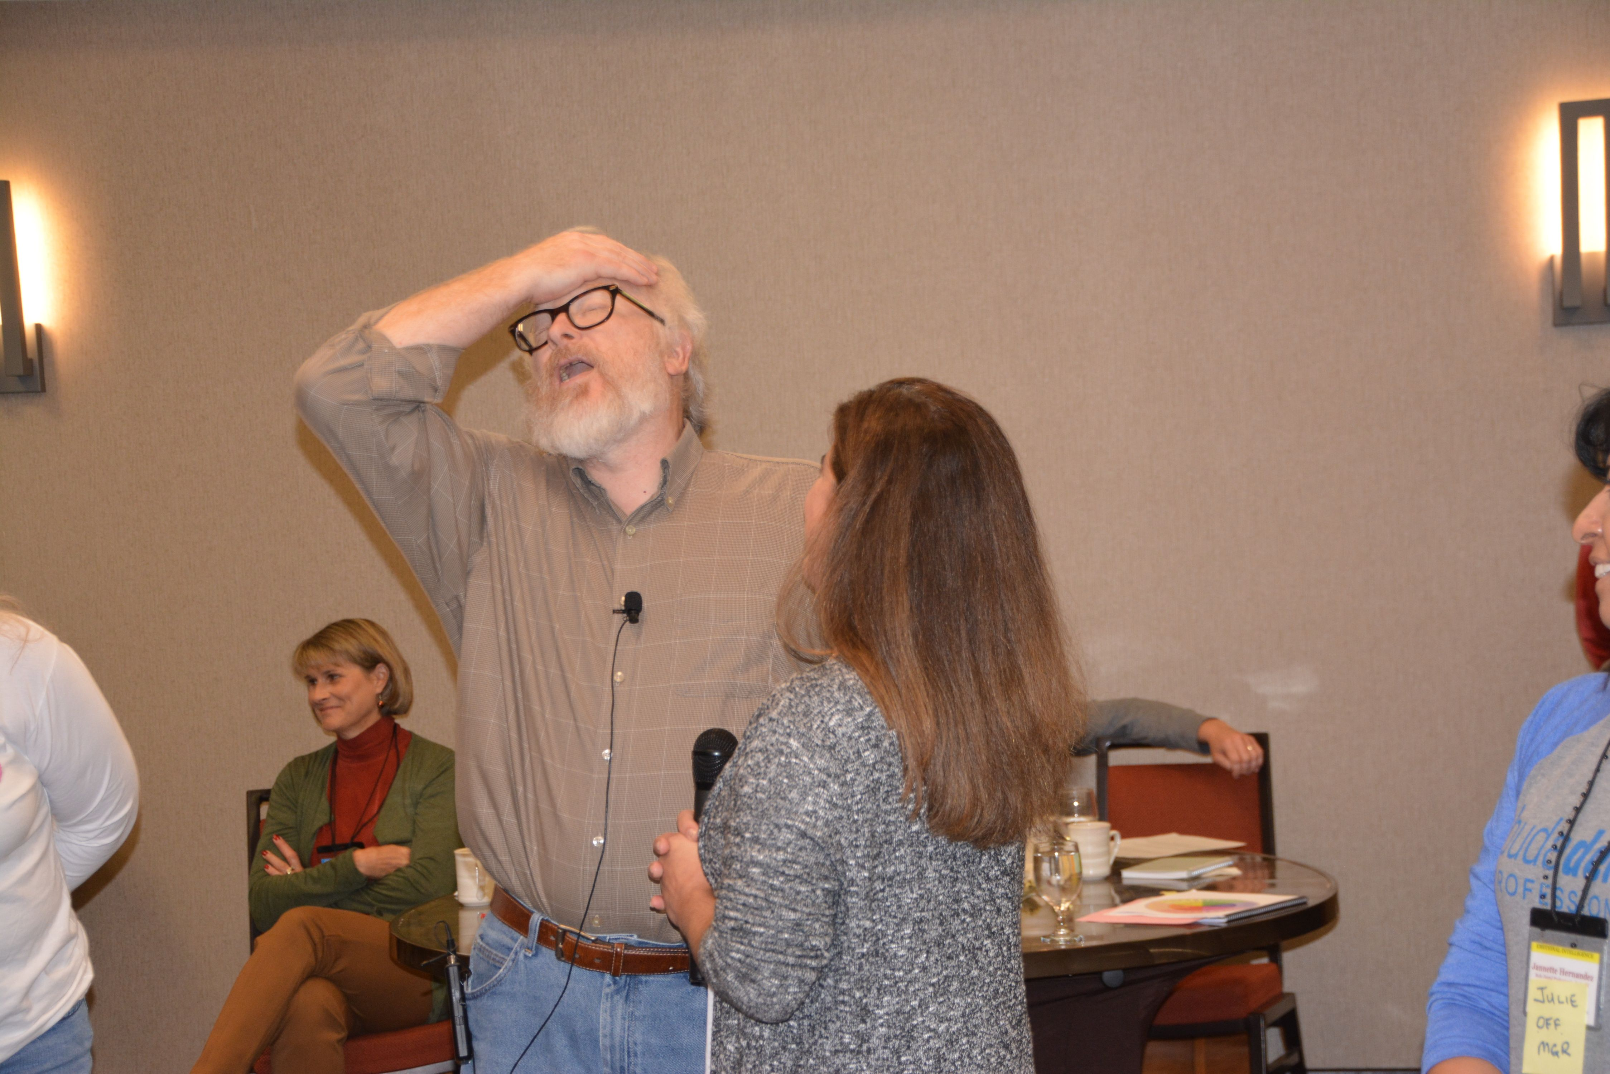
“As a pediatric practice, we deal with both the emotions of the children and their parents, plus we tend to have large teams requiring EI leadership. Your EI is simply a must!”
Mark Kogut, DDS, MS
Dallas, Tx.
Discover how hidden group and
interpersonal dynamics affect
team performance, impacts treatment acceptance, and
practice climate with Master Storyteller and MEd., LMFT, Licensed Professional Counselor,
Bill Woodburn.

Just a Few of the Proven Benefits for You and Your Team

- Gain skills to become a highly effective, balanced, and authentic leader

- Elevated emotional intelligence dramatically increases treatment acceptance, and builds a cohesive, more self-managing, empowered team-based practice.

- Learn less stressful, most effective, and positive conflict resolution strategies.

- Dramatically improve your personal boundaries, empathy and listening skills.

- Learn to apply the Six Styles of Highly Effective Leaders who Get Results.

- Prevent hidden emotional dynamics from wrecking your best intentions... in teamwork, accountability, and case acceptance

- Create a Self-Directed Learning Plan that charts a step-by-step path to your ideal highly effective professional and personal self.

- Use real-life & practice leadership scenarios to learn new behaviors, thoughts & feelings in a safe, supportive environment (65% of workshop will be hands-on)

“I left Austin with an EI – hangover, in love with my team and confident that I can become the leader I imagine. These are rough times in Michigan and in dentistry. You two together (the combination of psychology and advanced restorative dentistry) are amazing.” Susan Maples, DDS
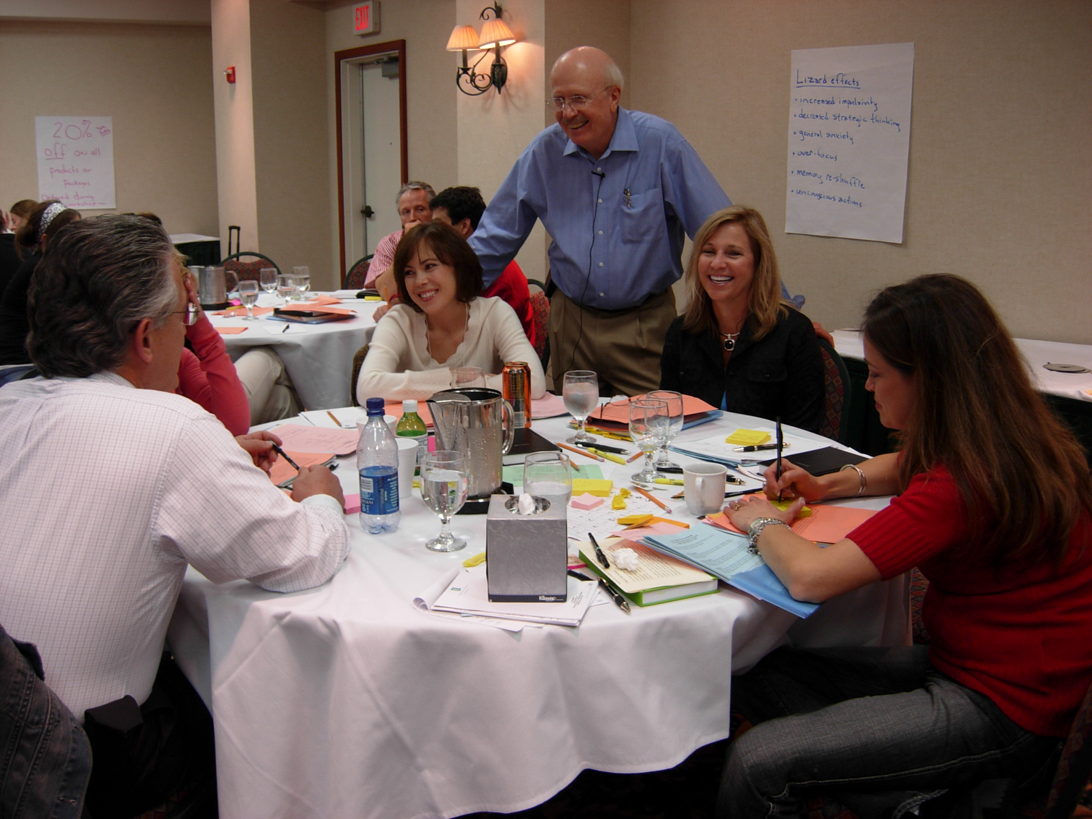
“The great thing about this workshop is that what I learned about EI will not only make me a much more effective team member - it will make me a better wife, mother and whole person.” Heather Shoemaker

“As a performance coach to dentists for over 28 years, I have continually seen a pattern. Often the most gifted intellectually (high I.Q.) and technically excellent dentists seem to be on a never-ending journey of CE to elevate their technical competency. Yet end up frustrated and even depressed with recurring staff problems and no matter how hard they try, their patients do not routinely choose the fine dentistry that they’ve learned to deliver.

At the same time, I encounter good dentists with patients wanting the dentistry they offer. I am convinced one must have technical competency, but the difference ... particularly among the star performers is emotional intelligence!

Remember every major purchasing decision is first an emotional decision - that is then backed up by enough logic to justify it to yourself and others.” ~ Robert Frazer, DDS

Comments from Previous EI Workshop Participants
- “This workshop empowered and inspired me and my team like none we’ve taken in over 25 years! The EI skills we learned will allow us to grow our sense of community and serve our patients in a truly transformational way. We’ll be back again – you just can’t get enough EI!” Mike Robichaux, DDS ~ Slidell, LA

REGISTRATION FORM

Complete form below or call Peggy to register @ 512-346-0455
Scan completed form to peggy@frazeronline.com

Name _______________________________________ Preferred name ___________________

Address _________________________________________________________________________

City __________________________________ State ______ Zip Code _____________

Phone ( ) ____________________________ Email _________________________________

Preferred method of payment CK ____ Visa ____ MC ____ AMEX ____

Name on Credit Card ___________________________________

Address of Credit Card Statement: ___________________________________________________


Card No. __________________________________________

Expiration date ________________ CVC code ____________
EARLY BIRD DISCOUNT: SAVE $100/person
BY REGISTERING BY Nov 18, 2022!

First Attendee: $1690 $1,690.00

Additional Attendees: $1090 x #_______ __________
Early Bird Discount – Less $100/person X #____ - __________
6 – 7 Attendees same office receive a 5% discount - __________
8 or more Attendees same office receive a 10% discount - __________
Total Investment……………………………………………………………………= __________
50% Deposit to be charged w/registration………………………… = __________ Balance to be charged January 10, 2023…………………………. = __________
The workshop will begin on Friday morning registration at 8:45 am. The workshop will conclude on Saturday afternoon at 4:30pm. Lunch is included each day of the workshop. One hour of CE credit is issued for each hour in the classroom.
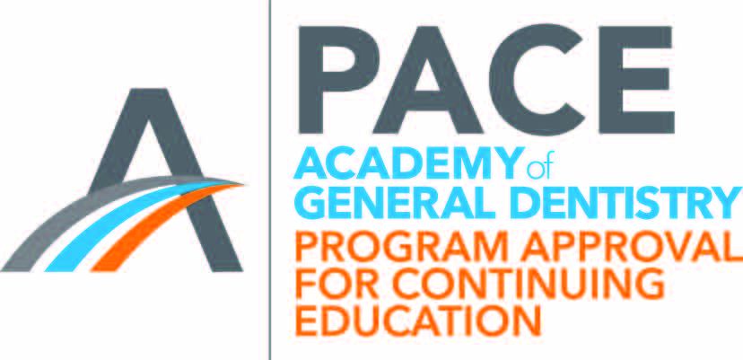
InsperoGroup(formerly R.L. Frazer & Associates) is designated as an Approved PACE Program Provider by the Academy of General Dentistry. The formal continuing education programs of this program Provider are accepted by AGD for Fellowship, Mastership and membership maintenance credit. Approval does not imply acceptance by the state or provincial board of dentistry or AGD Endorsement. The current term of approval extends from 10/1/2020 to 9/30/2023. Provider ID# 210606

R.L. Frazer & Associates, Inc.
512-346-0455
www.frazeronline.com bob@frazeronline.com

